Learn Git Cheat Sheet (Basic to Advanced Concepts)
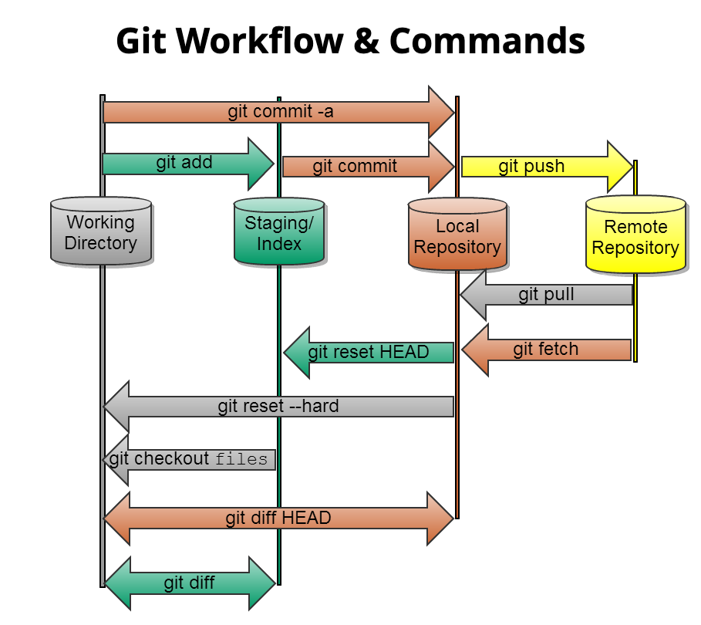

Git Workflow Notes (main & test branches)

Branches Used
- main → Stable / base branch
- test → Feature or testing branch

1. Clone the Repository- Download the remote repository to your local machine:
git clone <repository-url>
cd <repository-folder>

2. Create and Switch to test Branch

- Create a new branch from main and switch to it:
git checkout -b test

3. Make Changes and Commit (on test branch)
After modifying files:
git add .
git commit -m "commit message"

4. Sync main Branch with Remote
Before merging, make sure your local main branch is up to date:
git checkout main
git pull origin main

5. Merge Updated main into test
Switch back to test and merge the latest main changes:
git checkout test
git merge main

If conflicts occur:
- Resolve conflicts manually in the files
- Stage the resolved files:
git add .
- Complete the merge:
git commit

6. Push test Branch to Remote (Raise PR)
Push the test branch to the remote repository:
git push --set-upstream origin test
✅ This command links the local test branch with the remote test branch and is required only the first time you push.

7. Create Pull Request (PR)
- Go to your Git hosting service (GitHub / GitLab / Bitbucket)
- You will see a yellow banner: "test had recent pushes" → click Compare & pull request
- Create a Pull Request from test → main
- Add reviewers and description
- Resolve any review comments if needed

Summary Flow
clone repo
↓
create test branch
↓
make changes & commit
↓
update main
↓
merge main into test
↓
resolve conflicts
↓
push test
↓
raise PR

Git Installation Commands
Commands | Description
Git for Windows stand-alone installer. | For more Details Read Here
$ brew install git | Install Git with Homebrew on Mac OS
$ sudo port selfupdate | Install Git with MacPorts on Mac OS
$ sudo apt-get install git | Install Command for Linux
$ git --version | Shows the current version of your Git

Git Configuration & Setup

Commands | Description
git config --global user.name “Your Name” | Set your username globally.
git config --global user.email “youremail@example.com” | Set your email globally.
git config --global color.ui auto – | Set to display colored output in the terminal
git help | Display the main help documentation, showing a list of commonly used Git commands.

Initializing a Repository
Commands | Description
git init | Initializes a new Git repository in the current directory.
git init <directory> | Creates a new Git repository in the specified directory.
git clone <repository_url> | this Clones a repository from a remote server to your local machine.
git clone --branch <branch_name> <repository_url> | Clones a specific branch from a repository.  eg: git clone --branch dev https://github.com/username/repository.git

Basic Git Commands
Commands | Description
git add <file> | Adds a specific file to the staging area.
git add . or git add --all | Adds all modified and new files to the staging area.
git status | Shows the current state of your repository, including tracked and untracked files, modified files, and branch information.
git status --ignored | Displays ignored files in addition to the regular status output.
git diff | Shows the changes between the working directory and the staging area (index).
git diff <commit1> <commit2> | Displays the differences between two commits.
git diff --staged or git diff --cached | Displays the changes between the staging area (index) and the last commit.
git diff HEAD | Display the difference between the current directory and the last commit
git commit | Creates a new commit with the changes in the staging area and opens the default text editor for adding a commit message.
git commit -m “<message>” or git commit --message “<message>” | Creates a new commit with the changes in the staging area and specifies the commit message inline.
git commit -a or git commit --all | Commits all modified and deleted files in the repository without explicitly using git add to stage the changes.
git notes add | Creates a new note and associates it with an object (commit, tag, etc.).
git restore <file> | Restores the file in the working directory to its state in the last commit.
git reset <commit> | Moves the branch pointer to a specified commit, resetting the staging area and the working directory to match the specified commit.
git reset --soft <commit> | Moves the branch pointer to a specified commit, preserving the changes in the staging area and the working directory.
git reset --hard <commit> | Moves the branch pointer to a specified commit, discarding all changes in the staging area and the working directory, effectively resetting the repository to the specified commit.
git rm <file> | Removes a file from both the working directory and the repository, staging the deletion.
git mv | Moves or renames a file or directory in your Git repository.

Git Commit (Updated Commands)
Commands | Description
git commit -m “feat: message” | Create a new commit in a Git repository with a specific message to indicate a new feature commit in the repository.
git commit -m “fix: message” | Create a new commit in a Git repository with a specific message to fix the bugs in codebases
git commit -m “chore: message” | Create a new commit in a Git repository with a specific message to show routine tasks or maintenance.
git commit -m “refactor: message” | Create a new commit in a Git repository with a specific message to change the code base and improve the structure.
git commit -m “docs: message” | Create a new commit in a Git repository with a specific message to change the documentation.
git commit -m “style: message” | Create a new commit in a Git repository with a specific message to change the styling and formatting of the codebase.
git commit -m “test: message” | Create a new commit in a Git repository with a specific message to indicate test-related changes.
git commit -m “perf: message” | Create a new commit in a Git repository with a specific message to indicate performance-related changes.
git commit -m “ci: message” | Create a new commit in a Git repository with a specific message to indicate the continuous integration (CI) system-related changes.
git commit -m “build: message” | Create a new commit in a Git repository with a specific message to indicate the changes related to the build process.
git commit -m “revert: message” | Create a new commit in a Git repository with a specific message to indicate the changes related to revert a previous commit.

Branching and Merging
Commands | Description
git branch | Lists all branches in the repository.
git branch <branch-name> | Creates a new branch with the specified name.
git branch -d <branch-name> | Deletes the specified branch.
git branch -a | Lists all local and remote branches.
git branch -r | Lists all remote branches.
git checkout <branch-name> | Switches to the specified branch.
git checkout -b <new-branch-name> | Creates a new branch and switches to it.
git checkout — <file> | Discards changes made to the specified file and revert it to the version in the last commit.
git merge <branch> | Merges the specified branch into the current branch.
git log | Displays the commit history of the current branch.
git log <branch-d | Displays the commit history of the specified branch.
git log --follow <file> | Displays the commit history of a file, including its renames.
git log --all | Displays the commit history of all branches.
git stash | Stashes the changes in the working directory, allowing you to switch to a different branch or commit without committing the changes.
git stash list | Lists all stashes in the repository.
git stash pop | Applies and removes the most recent stash from the stash list.
git stash drop | Removes the most recent stash from the stash list.
git tag | Lists all tags in the repository.
git tag <tag-name> | Creates a lightweight tag at the current commit.
git tag <tag-name> <commit> | Creates a lightweight tag at the specified commit.
git tag -a <tag-name> -m “<message>” | Creates an annotated tag at the current commit with a custom message.

Remote Repositories
Commands | Description
git fetch | Retrieves change from a remote repository, including new branches and commit.
git fetch <remote> | Retrieves change from the specified remote repository.
git fetch --prune | Removes any remote-tracking branches that no longer exist on the remote repository.
git pull | Fetches changes from the remote repository and merges them into the current branch.
git pull <remote> | Fetches changes from the specified remote repository and merges them into the current branch.
git pull --rebase | Fetches changes from the remote repository and rebases the current branch onto the updated branch.
git push | Pushes local commits to the remote repository.
git push <remote> | Pushes local commits to the specified remote repository.
git push <remote> <branch> | Pushes local commits to the specified branch of the remote repository.
git push --all | Pushes all branches to the remote repository.
git remote | Lists all remote repositories.
git remote add <name> <url> | Adds a new remote repository with the specified name and URL.

Git Comparison
Commands | Description
git show | Shows the details of a specific commit, including its changes.
git show <commit> | Shows the details of the specified commit, including its changes.

Git Managing History
Commands | Description
git revert <commit> | Creates a new commit that undoes the changes introduced by the specified commit.
git revert --no-commit <commit> | Undoes the changes introduced by the specified commit, but does not create a new commit.
git rebase <branch> | Reapplies commits on the current branch onto the tip of the specified branch.
Why use Git?
Here are some of the reasons why you might want to use Git:
- Track changes to your code
- Collaborate on projects with others
- Maintain an organized code history
- Easily revert to previous versions when needed
- Release your code efficiently and manage versions
- Enhance productivity and code integrity in software development.

Here is a list of commonly used Git flags starting with -- (long options) and - (short options):
1. -a or --all
- Stages all changes (including file deletions) to the staging area.
- Example: git add -a or git add --all
2. -b or --branch
- Specifies the branch to checkout or operate on.
- Example: git checkout -b <branch_name>
3. -f or --force
- Forces the operation, overriding certain safety checks (e.g., force push or force add).
- Example: git push -f or git push --force
4. -p or --patch
- Allows interactively selecting hunks of changes to add.
- Example: git add -p or git add --patch
5. -u or --set-upstream
- Sets the upstream branch for the current branch.
- Example: git push -u origin <branch_name> or git push --set-upstream origin <branch_name>
6. -v or --verbose
- Provides more detailed output for commands.
- Example: git log -v or git log --verbose
7. -q or --quiet
- Suppresses output (useful to reduce clutter).
- Example: git push -q or git push --quiet
8. -n or --dry-run
- Shows what would happen without making any changes (for testing).
- Example: git clean -n or git clean --dry-run
9. -m or --message
- Specifies the commit message directly in the command.
- Example: git commit -m "Your message" or git commit --message "Your message"
10. -c or --config
- Allows setting configuration options for the current Git operation.
- Example: git commit -c <commit_id> or git commit --config <config_name>=<value>
11. -i or --interactive
- Starts an interactive mode (e.g., for rebase, add, etc.).
- Example: git rebase -i or git rebase --interactive
12. -n or --no
- Reverses a Git action, typically used to disable or negate options.
- Example: git merge --no-ff or git merge -n
13. --amend
- Amends the last commit (e.g., to change the commit message or add changes).
- Example: git commit --amend
14. --no-ff
- Ensures a merge commit is created even if it could be done with a fast-forward merge.
- Example: git merge --no-ff <branch_name>
15. --rebase
- Rebase the changes instead of merging.
- Example: git pull --rebase or git pull -r
16. --global
- Applies the configuration or setting globally for the current user.
- Example: git config --global user.name "Your Name"
17. --dry-run
- Shows what would happen if the command is executed, without making changes.
- Example: git clean --dry-run
18. --no-edit
- Does not open the commit message editor (commonly used during a merge).
- Example: git merge --no-edit
19. --stat
- Shows a summary of changes (e.g., number of files changed, lines added/removed).
- Example: git show --stat <commit_id>
20. --log
- Includes a commit log message in a merge commit.
- Example: git merge --log
21. --recurse-submodules
- Initializes and updates submodules recursively during a clone or fetch.
- Example: git clone --recurse-submodules <repository_url>
22. --no-verify
- Skips hooks like pre-commit or commit-msg during commit.
- Example: git commit --no-verify
23. --skip
- Skips the current patch during a rebase operation.
- Example: git rebase --skip
24. --verbose
- Provides detailed output for a command, useful for debugging.
- Example: git push --verbose
25. --sparse
- Enables sparse-checkout mode, checking out only part of the repository.
- Example: git clone --sparse <repository_url>
26. --rebase-merges
- Rebases merges, preserving the merge history.
- Example: git rebase --rebase-merges <commit_id>
27. --help
- Shows the help information for Git commands.
- Example: git commit --help
28. --date
- Sets a custom commit date.
- Example: git commit --date="2022-01-01"
29. --no-commit
- Prevents Git from committing after a merge.
- Example: git merge --no-commit
30. --index
- Performs a commit from the index (staging area), not the working directory.
- Example: git commit --index

